Task 4: Billing & Free Tier Monitoring
- Open CloudWatch Billing → Create Billing Alarm ($100).
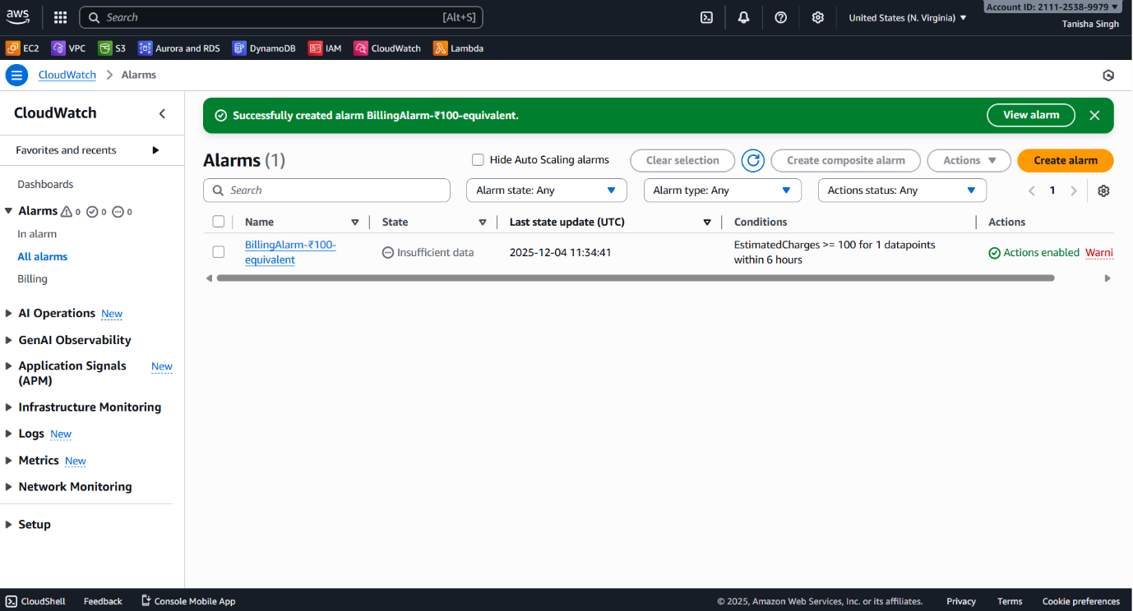
- Enable SNS email notifications.
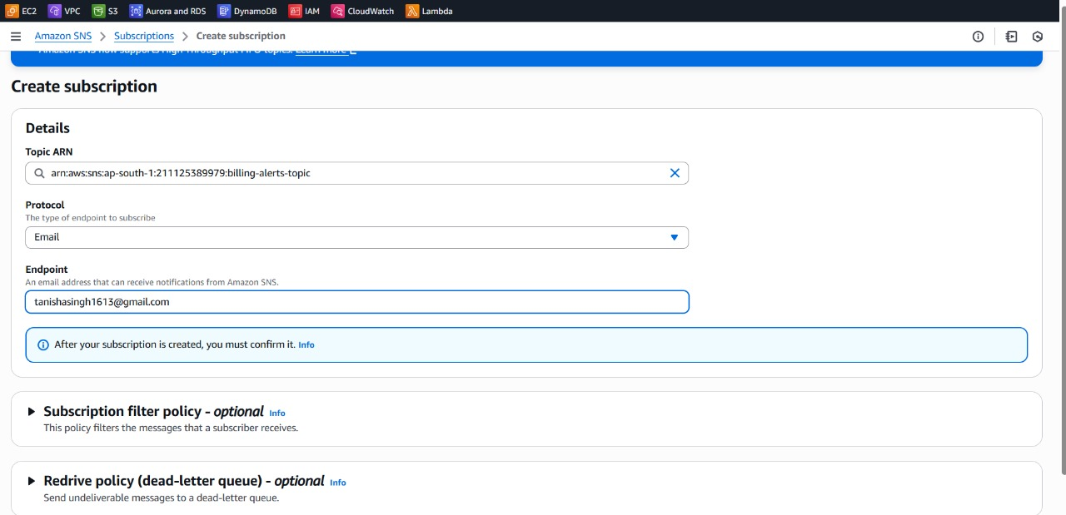

- Enable Free Tier Alerts from Billing Dashboard.
